Technical Scenario: E-Commerce Platform Development with Diagrams

Project: "QuickCart" E-Commerce System Development

Phase 1: Initial Contact & Discovery

Company: UrbanMart Retail
Need: Complete e-commerce platform with:
- Product catalog
- Shopping cart
- Payment gateway
- Admin dashboard
- Mobile app

Contact → ABC Software House
↓
Discovery Meeting (Zoom)
↓
Requirements Document
↓
Proposal & Contract Signed
Phase 2: Communication Architecture Diagram
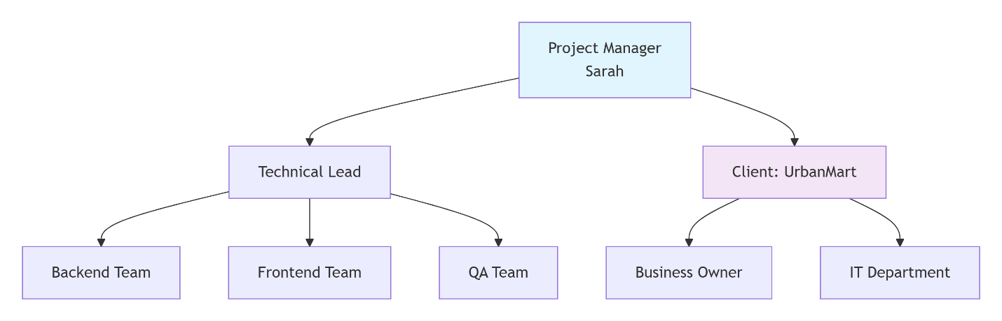

Phase 3: Technical Communication Channels
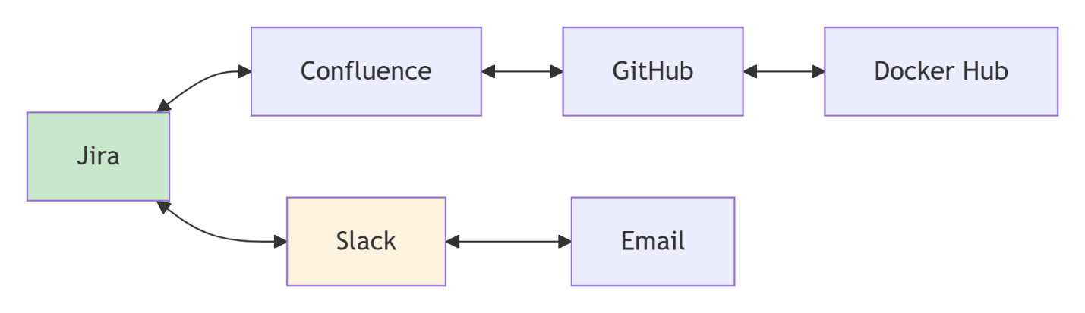

Phase 4: Daily Technical Standup Flow
┌─────────────────────────────────────────────────┐
│ DAILY STANDUP (9:00 AM) │
│ Duration: 15 mins | Platform: Microsoft Teams │
├─────────────────────────────────────────────────┤
│ Dev 1: │
│ ✅ Yesterday: Built cart API endpoints │
│ 🎯 Today: Integrate Stripe payment │
│ ⚠️ Blocked: Need SSL cert from client IT │
│ │
│ Dev 2: │
│ ✅ Yesterday: UI for product listing │
│ 🎯 Today: Responsive design for mobile │
│ ✅ No blockers │
│ │
│ QA: │
│ 🔍 Testing: Cart functionality │
│ 🐛 Found: 3 bugs (high priority) │
│ 📋 Logged: In Jira #EC-101, #EC-102, #EC-103 │
└─────────────────────────────────────────────────┘

Phase 5: Weekly Technical Sync Diagram
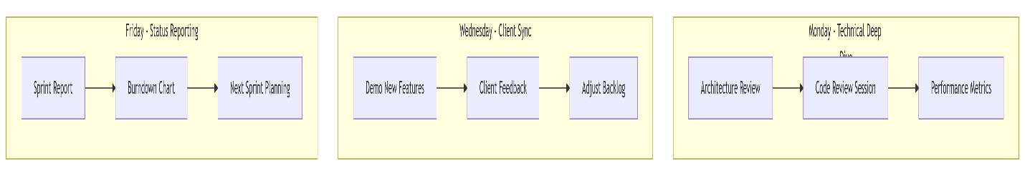

Phase 6: Technical Documentation Flow
┌─────────────────────────────────────────────────────────────┐
│ DOCUMENTATION HIERARCHY │
├─────────────────────────────────────────────────────────────┤
│ Level 1: Business Requirements │
│ • Use Case Diagrams (Mermaid) │
│ • User Stories (Jira/Confluence) │
│ │
│ Level 2: Technical Specifications │
│ • API Documentation (Swagger/Postman) │
│ • Database Schema (ER Diagrams) │
│ • System Architecture (UML Diagrams) │
│ │
│ Level 3: Implementation Details │
│ • Code Comments (In-line) │
│ • README.md files (GitHub) │
│ • Deployment Guides (Docker/Kubernetes) │
│ │
│ Level 4: Operational │
│ • Runbooks (Troubleshooting) │
│ • Monitoring Dashboards (Grafana) │
│ • Backup/Recovery Procedures │
└─────────────────────────────────────────────────────────────┘

Swagger and Postman are tools used for API documentation, testing, and collaboration—but they serve different purposes.

Phase 7: API(Application Programming Interface) Communication Example
# API Development Communication Flow
Feature: User Registration
Timeline: Sprint 3 (Days 1-5)

Communication Events:
1. Day 1: API Contract Shared (Swagger YAML)
├── Sent to: Frontend Team, QA, Client IT
├── Channel: GitHub + Slack
└── Review Deadline: 24 hours

2. Day 2: Feedback Incorporated
├── Changes: Added email verification field
├── Version: v1.1
└── Approval: Email confirmation from client

3. Day 3-4: Development
├── Daily commits with PR (Pull Requests)
├── Code review comments in GitHub
└── Automated tests in CI/CD pipeline

4. Day 5: Testing & Deployment
├── QA tests with Postman collection
├── Performance test results in Grafana
└── Deployed to Staging, client notified via email
A Pull Request (PR) is a GitHub/GitLab workflow feature used to propose, review, and merge code changes into a shared codebase.

What is a Pull Request?
A Pull Request:
- Compares changes from one branch to another (usually → main)
- Shows what code was added, changed, or removed
- Allows code review and discussion
- Runs CI checks before merging

Phase 8: Incident Communication Protocol
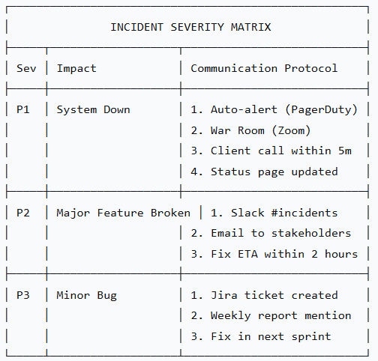

Phase 9: Deployment Communication
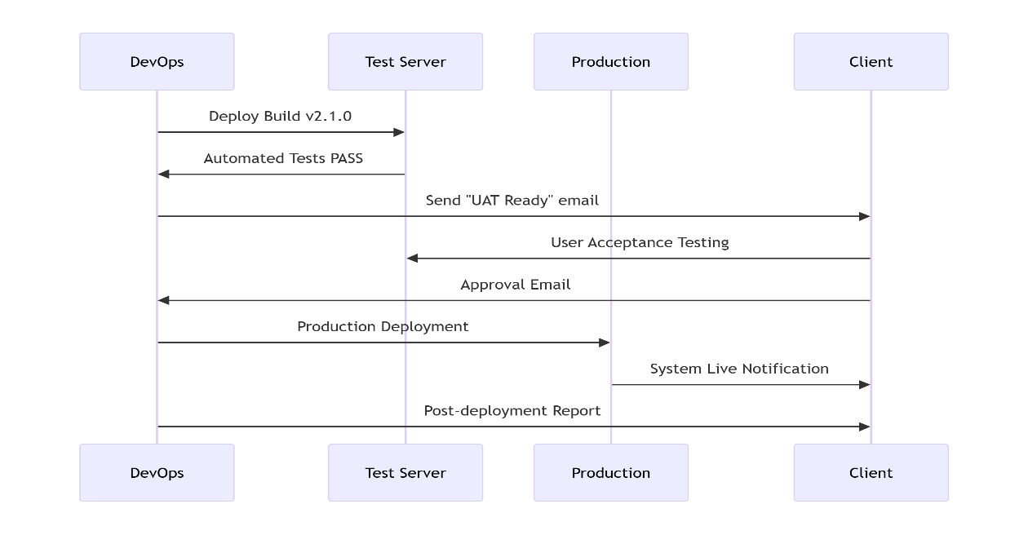

Phase 10: Metrics & Reporting Dashboard
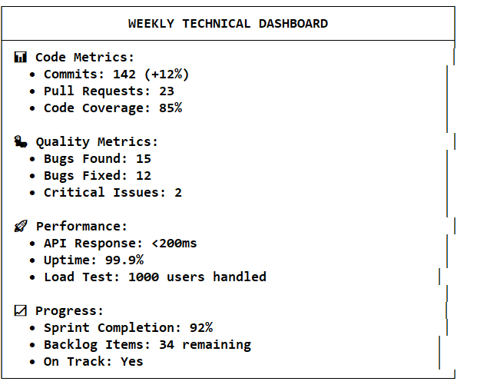

Phase 11: Handover & Knowledge Transfer
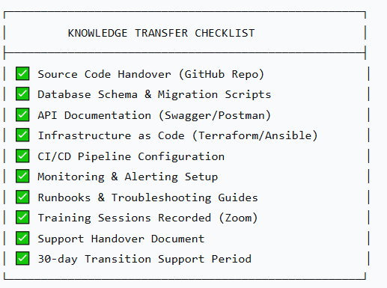

Jira
- A project and issue tracking tool by Atlassian
- Used to manage tasks, bugs, user stories, and sprints
- Helps teams plan work, track progress, and manage workflows (Agile, Scrum, Kanban)

Confluence
- A documentation and knowledge-sharing platform by Atlassian
- Used for project documentation, technical specs, meeting notes, and runbooks
- Often linked with Jira issues so documentation and tasks stay connected

GitHub
- A source code hosting and version control platform
- Uses Git to manage code changes and collaboration
- Supports pull requests, code reviews, CI/CD workflows, and issue tracking

Docker Hub
- A container image registry
- Stores and distributes Docker images (packaged applications with all dependencies)
- Commonly used in CI/CD pipelines to deploy applications consistently across environments

Slack
- A team communication and collaboration tool
- Used for real-time messaging, channels, alerts, and integrations
- Receives notifications from tools like Jira, GitHub, and CI/CD systems

Email
- A formal communication channel
- Used for notifications, approvals, reports, and external communication
- Often integrated with Slack and Jira for alerts and updates

How they work together (arrows meaning)
- Jira ↔ Confluence
Issues link to documentation; docs reference tasks and requirements.
- Confluence ↔ GitHub
Technical docs link to repositories, code, and architecture details.
- GitHub ↔ Docker Hub
Code builds Docker images and pushes them to Docker Hub.
- Jira ↔ Slack
Task updates, comments, and status changes trigger Slack notifications.
- Slack ↔ Email
Alerts and messages can flow between real-time chat and email.

Big Picture
This setup supports the full software development lifecycle:
- Plan → Jira
- Document → Confluence
- Code → GitHub
- Package & Deploy → Docker Hub
- Communicate → Slack & Email

CI/CD stands for Continuous Integration and Continuous Delivery (or Deployment).
It’s a practice that automates building, testing, and releasing software so changes move to users faster and more reliably.

CI — Continuous Integration
What it means:
Developers frequently merge code changes into a shared repository.
What happens automatically:
- Code is pulled from GitHub
- Build starts
- Automated tests run
- Code quality checks run
Goal:
Catch bugs early and ensure new code doesn’t break existing functionality.
Example:
Every time someone pushes code to GitHub, tests run automatically.

CD — Continuous Delivery / Continuous Deployment

Continuous Delivery
- Code is always in a deployable state
- Deployment requires manual approval

Continuous Deployment
- Code is automatically deployed after passing tests
- No manual approval
Goal:
Release software quickly, safely, and repeatedly.

Typical CI/CD Pipeline (Simple Flow)
- Developer commits code → GitHub
- CI tool runs (GitHub Actions, Jenkins, GitLab CI)
  - Build
  - Test
  - Lint / Security checks
- Docker image built
- Image pushed to Docker Hub
- Deploy to environment (Dev / QA / Prod)
- Notifications sent → Slack / Email
- Status updated → Jira

Common CI/CD Tools
- CI/CD engines: GitHub Actions, Jenkins, GitLab CI, CircleCI
- Containerization: Docker
- Registries: Docker Hub, AWS ECR
- Deployment: Kubernetes, Helm, Terraform
- Monitoring: Prometheus, Grafana

Why CI/CD is important
- 🚀 Faster releases
- 🐞 Fewer bugs in production
- 🔁 Repeatable and reliable deployments
- 🤝 Better collaboration
- 🔐 Improved security through automated checks

One-line summary
CI/CD is an automated pipeline that builds, tests, and deploys code every time it changes.

ETA stands for Estimated Time of Arrival (or Estimated Time to Completion, depending on context).

What ETA means
It is a best-guess estimate of when something will be finished or delivered.

Common meanings by context

Project / Software development
- When a task, feature, or release is expected to be completed
- Example:
“The bug fix ETA is tomorrow by EOD.”

CI/CD & DevOps
- Time when a build, deployment, or pipeline will finish
- Example:
“Deployment ETA: 10 minutes.”

Delivery / Logistics
- When a package, service, or person will arrive
- Example:
“Courier ETA is 6 PM.”

Where ETA is used in your toolchain
- Jira: ETA for issue or sprint completion
- Slack / Email: Sharing expected completion time
- CI/CD pipelines: Build or deploy completion estimate

Important note
ETA is not a guarantee — it can change due to:
- Bugs
- Failed tests
- Dependencies
- Infrastructure issues

Simple definition
ETA = When we expect something to be done or arrive.

SSL stands for Secure Sockets Layer
(today it’s technically TLS, but everyone still says SSL).

What SSL is
SSL is a security technology that:
- Encrypts data between a user’s browser and a server
- Prevents data from being read or altered by attackers

What SSL does (simple)
It makes:
- 🔒 Websites secure
- 🌐 http:// → https://
- 🔑 Data encrypted (passwords, payments, personal info)

Why SSL is required
- Protects credit card and login data
- Prevents man-in-the-middle attacks
- Required by:
  - Stripe / payments
  - Browsers (Chrome shows warnings without it)
  - Security standards (PCI-DSS)

How you know a site has SSL
- URL starts with https://
- 🔒 Padlock icon in the browser
- Certificate issued by a Certificate Authority (CA)

Who provides SSL
- Client IT team
- Hosting providers
- Certificate Authorities like:
  - Let’s Encrypt
  - DigiCert
  - GlobalSign

In your context
“Blocked: Need SSL cert from client IT”
Means:
- Payment integration cannot continue
- Server must have an SSL certificate installed
- Waiting on client IT to set it up

One-line definition
SSL encrypts data so information sent over the internet stays private and secure.

